Serial to Serial

Dual Serial Port Monitor and Redirector

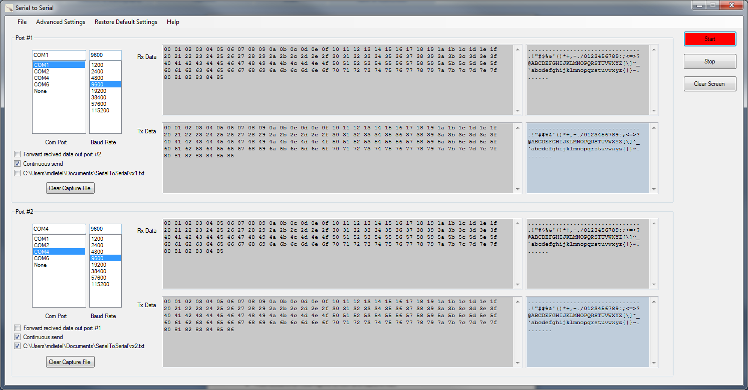

# Table of Contents

Table of Contents 2

Introduction 2

Operation Reference 3

General Settings 3

Com Port and Baud Rate 3

Forward received data out port #n 4

Virtual Serial Port (Serial over IP) 4

Continuous Send 4

Capture to File 4

Example of captured file: 5

Advanced Settings 6

Using Serial to Serial 7

Start 7

Stop 8

Clear Screen 8

Menu Options 8

File – Set Capture Folder 8

File – Load Settings 8

File – Save Settings 9

Restore Default Settings 9

Help 9

Sniffer Cables 10

Dual port full duplex cable 10

Single port half duplex cable 11

# Introduction

Serial to Serial is a serial port monitor and redirector application with the following features:

* Monitoring of two ports
* Redirection allows received data of one port to be forwarded out the other port
* On screen display of sent and received data in binary hexadecimal and text format
* Capture files in binary and text format
* Push buttons for clearing the screen and capture files
* Persistent settings. All settings automatically saved when the application is closed and restored the next time the application is started

# Operation Reference

## General Settings

The General Settings are located on the main screen and consists of the following parameters for each of the two ports:

* Com Port name
* Baud Rate
* Forward received data (redirection)
* Continuous send
* Capture to file

### Com Port and Baud Rate

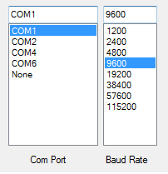

To modify the Com Port name and Baud Rate highlight the desired selection with the mouse. Only ports available on your machine will be displayed in the selection list.

### Forward received data out port #n (redirection)



When enabled all data received on the port will be forwarded out the other port. This is useful when using two ports for in line sniffing or monitoring a remote device using a virtual serial port.

#### Virtual Serial Port (Serial over IP)

Another use for forwarding is accessing a remote device using a **virtual serial port or Serial over IP**. Serial over IP devices are commonly available and consist of a hardware unit with a RS-232 port and Ethernet port for connecting the target device to a TCP/IP network or the Internet. Serial over IP devices typically include a driver which is installed on the PC for associating the virtual serial port to a Com Port name. Follow the manufactures instructions for installing the driver. Using a virtual serial port and the Serial to Serial application setup with the Forward option enabled for both ports a serial device can be monitored and debugged from a remote location.

### Continuous Send



When enabled a continuous stream of data (00H – 0FFH) will be sent out the respective port

### Capture to File



When enabled all data received on the port will be captured to the specified text file. To change the directory location click File-Set Capture Folder from the main menu, a browse dialog will popup allowing you to select a new location.

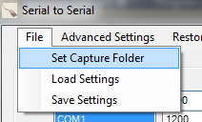

The capture file can be cleared at any time by clicking the Clear Capture File button



#### Example of capture file printout

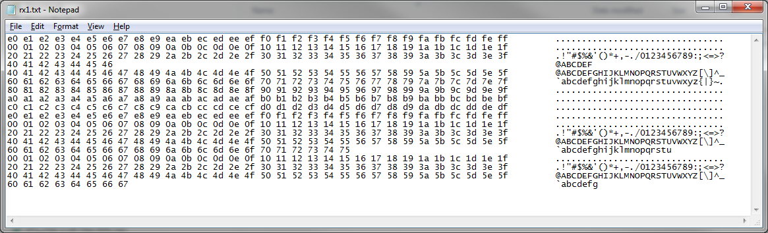

## Advanced Settings

Advanced Settings is accessed from the main menu and displays a dialog for the following parameters:

* Handshake
* Parity
* Stop Bits
* Data Bits

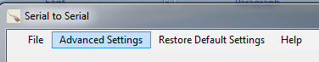

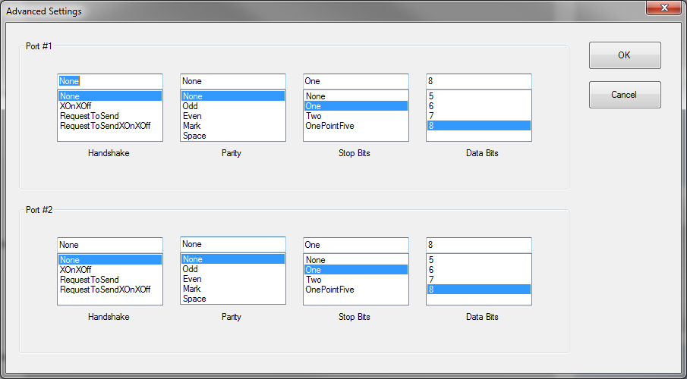

To modify the parameters highlight your desired setting with the mouse. Click Close to save your changes and close the Advanced Settings dialog or Cancel to close the dialog without saving your modifications.

## Using Serial to Serial

After making your desired modifications to the General and Advanced parameters you are ready to begin using Serial to Serial. Operation of Serial to Serial is controlled by three push buttons:

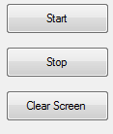

### Start

Push the **Start** button to open the selected ports and begin monitoring and file capture. All data send and received on the selected ports will be displayed as data is received and transmitted. Data is displayed in binary hex format on the left and text (ASCII) format on the right.

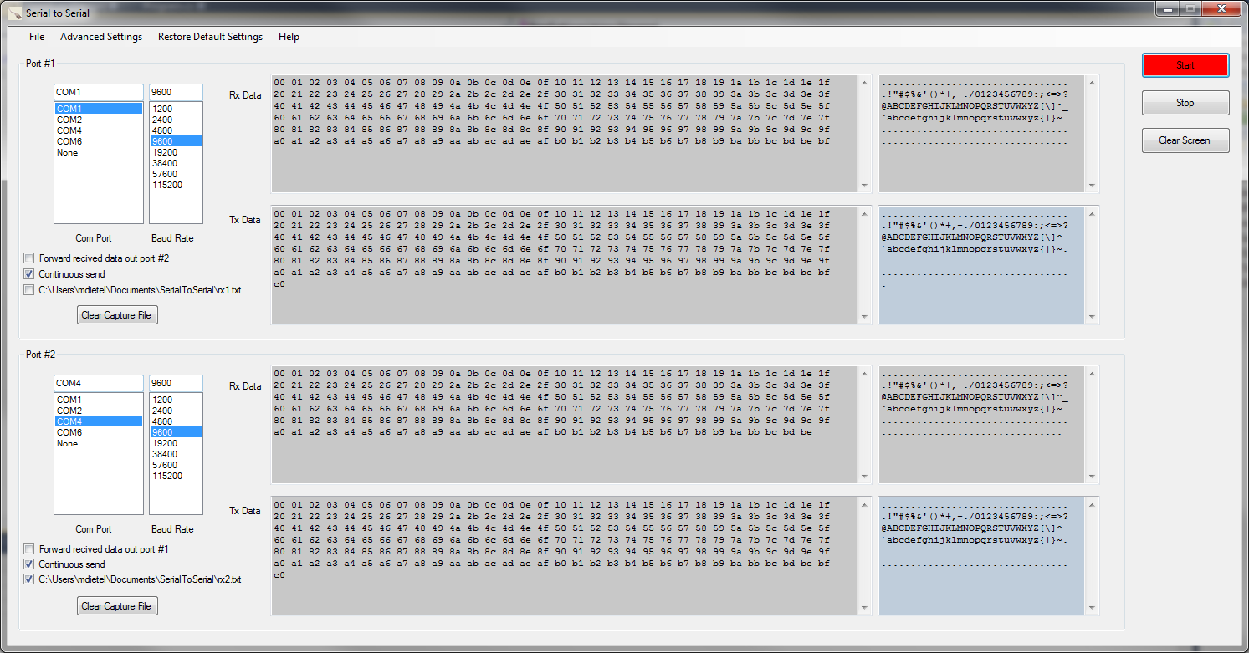

### Stop

Push the **Stop** button to close the ports and terminate monitoring and capture

### Clear Screen

Push the **Clear Screen button** to clear the data monitor text boxes. The **Clear Screen** button can be pressed while the port is open to clear the screen at any time.

## Menu Options

### File – Set Capture Folder

Use the File – Set Capture Folder menu item to change the location directory for capture files.

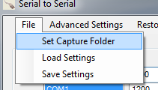

### File – Load Settings

Use the **Load Settings** menu item to load a previously saved settings file. All settings general and advanced will be restored.

### *File – Save Settings*

Use the **Save Settings** menu item to save the currently selected settings. All settings general and advanced will be saved to the selected file.

Note: All settings are automatically saved when the program is closed and restored the next time the application is opened.

### Restore Default Settings

Use the **Restore Default Settings** menu item to restore all settings to their factory default values.



### Help

Displays menu items for displaying the **Operation Reference** manual and **About** dialog

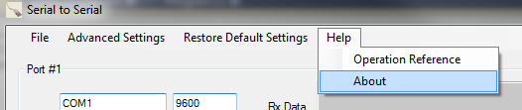

# Sniffer Cables

## Dual port full duplex cable

The following cable will monitor both directions of a serial port. Each direction will be monitored on a different port.

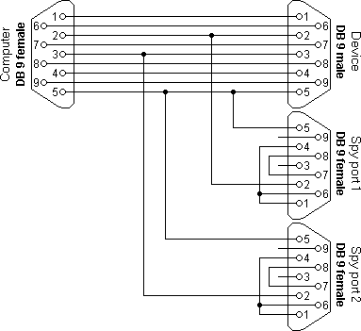

## Single port half duplex cable

The following cable will display both directions to a single channel. This can only be used for half-duplex protocols. Note: Most serial protocols are half duplex.

